|  |
| --- |
| Logo, company name  Description automatically generatedAIC, MATHEMATICS LEARNING AREA  **YEAR 11 MATHEMATICS APPLICATIONS – UNIT 1**  **Assessment type: Response**  **TASK 4 – TEST 3** |

Student Name: __________________________ ID: ___________ Date: _______

**TIME ALLOWED FOR THIS PAPER**

**Reading and Working time for this paper: 50 minutes in class under test conditions**

**MATERIAL REQUIRED FOR THIS PAPER**

*TO BE PROVIDED BY THE SUPERVISOR*

Question/answer booklet for sections one and two.

*TO BE PROVIDED BY THE CANDIDATE*

*Standard Items:* pens, pencils, pencil sharpener, highlighter, eraser, ruler, drawing templates

**IMPORTANT NOTE TO CANDIDATES**

No other items may be taken into the examination room. It is **your** responsibility to ensure that you do not have any unauthorised notes or other items of a non-personal nature in the examination room. If you have any unauthorised material with you, hand it to the supervisor **before** reading any further.

**Structure of this paper**

|  |  |  |  |
| --- | --- | --- | --- |
| Section | Number of questions available | Suggested working time (minutes) | Marks available |
| **1- Non-calculator** | **4** | **15** | **15** |
| **2- Calculator assumed** | **6** | **35** | **30** |
|  | | **Marks available:** | **45** |
| **Task Weighting** | **8%** |

**Instructions to candidates**

* The rules for the conduct of this examination are detailed in the booklet *WACE* *Examinations Handbook*. Sitting this examination implies that you agree to abide by these rules.
* Answer the questions in the spaces provided.
* Spare answer pages can be used. If you need to use them, indicate in the original answer space where the answer is continued.

### SCSA Content – Topic 1.3: Shape and measurement

### Pythagoras’ theorem

### 1.3.1 use Pythagoras’ theorem to solve practical problems in two dimensions and for simple applications in three dimensions

Mensuration

1.3.2 solve practical problems requiring the calculation of perimeters and areas of circles, sectors of circles, triangles, rectangles, parallelograms and composites

1.3.3 calculate the volumes of standard three-dimensional objects, such as spheres, rectangular prisms, cylinders, cones, pyramids and composites in practical situations, for example, the volume of water contained in a swimming pool

1.3.4 calculate the surface areas of standard three-dimensional objects, such as spheres, rectangular prisms, cylinders, cones, pyramids and composites in practical situations, for example, the surface area of a cylindrical food container

Similar figures and scale factors

1.3.5 review the conditions for similarity of two-dimensional figures, including similar triangles

1.3.6 use the scale factor for two similar figures to solve linear scaling problems

1.3.7 obtain measurements from scale drawings, such as maps or building plans, to solve problems

1.3.8 obtain a scale factor and use it to solve scaling problems involving the calculation of the areas of similar figures and surface areas and volumes of similar solids

**Non-Calculator section 1:**

**Total marks: /15 marks Time allocated: 15 minutes**

**Question 1 [2 marks]**

The circular spinner drawn right has an area of 234 cm2. Determine the area of the shaded section

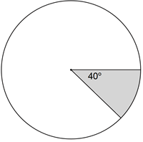

**Question 2 [1, 2 = 3 marks]**

A fire started 600 m due East of Jason’s house and 800 m due South of Izzy’s house. Jason wants to go from his house to Izzy’s house.

1. Draw a labelled diagram to show the locations of the two houses and the fire.

(ii) Determine the shortest distance from Jason’s house to Izzy’s house.

**Question 3 [1, 1, 1, 2 = 5 marks]**

ABCD is a square with sides of 4 cm. BG divides the square into a triangle BCG and a trapezium ABGD. The distance from D to G is 1 cm.

1. 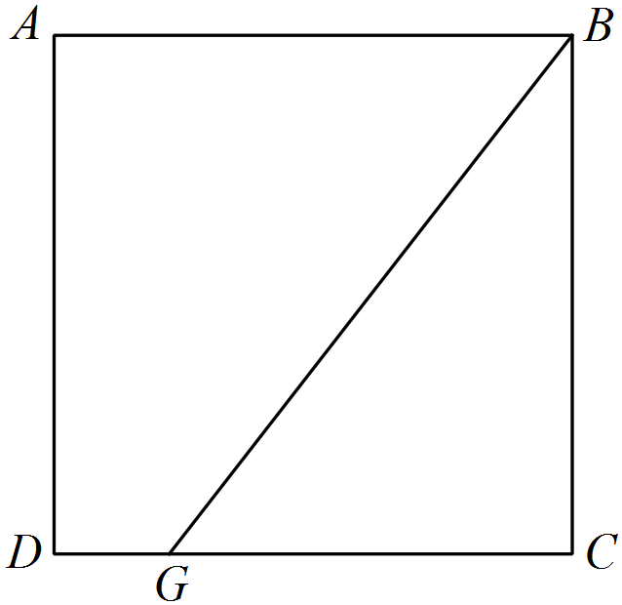Calculate the length of BG.
2. Calculate the area of triangle BCG.
3. Calculate the area of the trapezium ABDG.
4. Express the area of the trapezium as a percentage of the square’s area.

**Question 4 [1, 3, 1 = 5 marks]**

The diagram below, not drawn to scale, shows two similar right triangles.

1. Calculate the scale factor for the larger triangle relative to the smaller.
2. Determine the length of side $BC$, the length of side $DE$ and the length of side $DF$.
3. Calculate how many times greater the area of the large triangle is compared to the area of the small triangle.

**Calculator Allowed section 2:**

**Name: ___________________________________________**

**Total marks: /30 marks Time allocated: 35 minutes**

**Question 1 [2, 2 = 4 marks]**

(a) The two triangles shown below are similar. Determine the lengths *a* and *b*.

1. An image, with one side that is 13 cm long, is enlarged so that the same side now measures 39 cm. If the original area of the image was 200 cm 2, determine the area of the enlargement.

**Question 2 [2, 2 = 4 marks]**

Red Stagg energy drink is sold in cylindrical cans of radius 4 cm and height 15 cm. To advertise Redd Stagg the company constructs plastic blow-up scale models of the can.

(a) The model has a radius of one metre, determine the height of the model. Give your answer in metres.

(b) The capacity of a can is 240 $π$ mL. State the capacity of the model in litres. Leave your answer in terms of $π$.

**Question 3 [2, 2, 2 = 6 marks]**

Fatima has baked a cake to celebrate Eid. It is cylindrical in shape, 30 cm wide and 8 cm high.

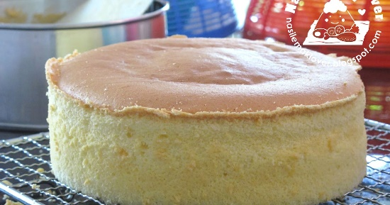

[This Photo](http://nasilemaklover.blogspot.ch/2012/09/basic-plain-sponge-cake.html) by Unknown Author is licensed under [CC BY-SA-NC](https://creativecommons.org/licenses/by-nc-sa/3.0/)

[This Photo](https://www.laavyskitchen.com/2015/02/rose-birthday-cake.html) by Unknown Author is licensed under [CC BY-NC-ND](https://creativecommons.org/licenses/by-nc-nd/3.0/)

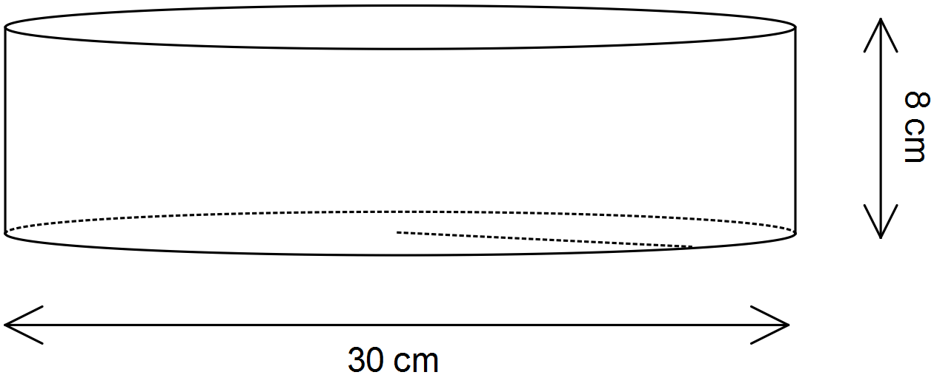

1. Fatima wishes to place paper trimming right around the outside of the cake. Her trimming is 8 cm wide. What is the minimum length that it should be? Give your answer to 2 decimal places.

(b) Fatima is going to ice the cake on the top and around the outside (not on the bottom).

1. How much of the cake will need to be iced? Give your answer to the nearest whole number.
2. If Fatima needs 100 g of sugar for each 1000 cm2 of icing that she makes, how much sugar will she need? Give your answer to 2 decimal places.

**Question 4 [1, 3, 2 = 6 marks]**

A 4.5 m long ladder rests on level ground between two buildings with one end, A, on the ground and the other end touching point B, at a height of 4.25 m up the wall of one of the buildings. The ladder is then rotated about A so that the other end touches point C, 3.6 m up the opposite wall.

1. Add the above dimensions to the sketch below.

(b) Determine the horizontal distance between the two buildings, giving your answer correct to two decimal places

(c) A length of wire is stretched tightly from B to C. Determine the length of this piece of wire.

**Question 5 [1, 2, 3 = 6 marks]**

A solid cone of radius 9 cm and height 12 cm is placed symmetrically atop a solid hemisphere of radius 11 cm to form the composite solid shown below.

(a) Use Pythagoras’ Theorem to calculate the slant height of the cone.

(b) Determine the area of the shaded ring, between the cone and the hemisphere, as shown in the diagram above. Give your answer to two decimal places.

(c) Determine the surface area of the composite solid. Give your answer to two decimal places.

**Question 6 [2, 2 = 4 marks]**

The diagram gives the internal dimensions of a swimming pool.

1. The pool is to be filled with water to a level that is 15 cm below the top edge of the pool. Find the volume of water needed to fill the pool in kL.
2. How long will it take to fill this pool to the required level if water to this pool can be supplied at a constant rate of 120 litres per minute? Give your answer in hours and minutes.

END OF TEST

**EXTRA WORKING OUT PAGE**